**LAB 2**

**1.** **Write a program that takes a student's score as input and outputs the corresponding grade based on the following scale:**

**A: 90-100**

**B: 80-89**

**C: 70-79**

**D: 60-69**

**F: 0-59**

**package** Session;

**import** java.util.Scanner;

**public** **class** Grade {

**public** **static** **void** main(String[] args) {

Scanner s = **new** Scanner(System.***in***);

System.***out***.print("Enter the student's score: ");

**int** score = s.nextInt();

// Determine the grade using switch-case

**char** grade;

**switch** (score / 10) { // Switch based on the tens digit of the score

**case** 9:

grade = 'A';

**break**;

**case** 8:

grade = 'B';

**break**;

**case** 7:

grade = 'C';

**break**;

**case** 6:

grade = 'D';

**break**;

**default**:

grade = 'F';

**break**;

}

// Output the grade

System.***out***.println("The grade is: " + grade);

s.close();

}

}

**Output :-**

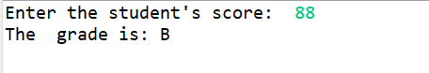

**2.     Write a program to check if a given year is a leap year. (A year is a leap year if it is divisible by 4 but not by 100, or it is divisible by 400.)**

**package** Session;

**import** java.util.Scanner;

**public** **class** LeapYear {

**public** **static** **void** main(String[] args) {

Scanner s = **new** Scanner(System.***in***);

System.***out***.print("Enter a year to check leap year: ");

**int** year = s.nextInt();

// Check if the year is a leap year

**boolean** leapyear = **false**;

// Condition for leap year

**if** ((year % 4 == 0 && year % 100 != 0) || (year % 400 == 0)) {

leapyear = **true**;

}

**if** (leapyear) {

System.***out***.println(year + " is a leap year.");

} **else** {

System.***out***.println(year + " is not a leap year.");

}

s.close();

}

}

**Output :-**

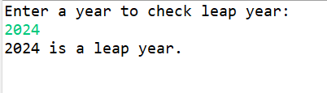

**3.     Write a program that takes an integer as input and checks if it is positive, negative, or zero.**

**package** Session;

**import** java.util.Scanner;

**public** **class** CheckPNZ {

**public** **static** **void** main(String[] args) {

Scanner s = **new** Scanner(System.***in***);

System.***out***.print("Enter an integer number: ");

**int** number = s.nextInt();

**if** (number > 0) // Check if the number is positive

{

System.***out***.println(number + " is a positive number.");

}

**else** **if** (number < 0)// Check if the number is negative

{

System.***out***.println(number + " is a negative number.");

}

**else** // else the number is zero

{

System.***out***.println("The number is zero.");

}

s.close();

}

}

**Output :-**

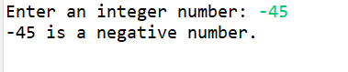

**4.     Write a program that prints numbers from 1 to 10 using a loop.**

**package** Session;

**import** java.util.Scanner;

**public** **class** Number1to10 {

**public** **static** **void** main(String[] args) {

Scanner s= **new** Scanner(System.***in***);

System.***out***.println("Choose which loop you want to run:");

System.***out***.println("1 For Loop");

System.***out***.println("2 While Loop");

System.***out***.println("3 Do-While Loop");

**int** choice = s.nextInt();

System.***out***.println("Enter the start number:");

**int** start = s.nextInt();

System.***out***.println("Enter the end number:");

**int** end = s.nextInt();

**switch** (choice) // using switch case for type of loops

{

**case** 1:

System.***out***.println("Running For Loop:");// for loop

**for** (**int** i = start; i <= end; i++) {

System.***out***.println(i);

}

**break**;

**case** 2:

System.***out***.println("Running While Loop:");// while loop

**int** i = start;

**while** (i <= end) {

System.***out***.println(i);

i++;

}

**break**;

**case** 3:

System.***out***.println("Running Do-While Loop:");// do while loop

i = start;

**do** {

System.***out***.println(i);

i++;

} **while** (i <= end);

**break**;

**default**:

System.***out***.println("Invalid choice.");

// invalid choice if not enter the right option

**break**;

}

s.close();

}

}

**Output :-**

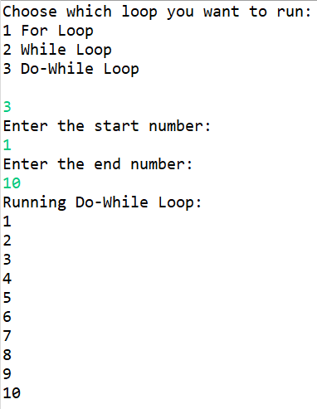

**5.     Write a program that takes an integer N as input and calculates the sum of entered numbers.**

**package** Session;

**import** java.util.Scanner;

**public** **class** SumofDigit {

**public** **static** **void** main(String[] args) {

Scanner s = **new** Scanner(System.***in***);

System.***out***.print("Enter number: ");

**int** number = s.nextInt();

**int** sum = 0;

**int** originalNumber = number;

**while** (number != 0)

{

// Get the last digit

**int** digit = number % 10;

// Add the last digit to sum

sum += digit;

// Remove the last digit from number

number /= 10;

}

System.***out***.println("The sum of digits of " + originalNumber + " is: " + sum);

s.close();

}

}

**Output :-**

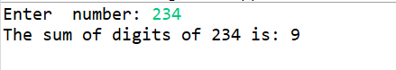

**6.     Write a program that takes an integer as input and prints its multiplication table up to 10.**

**package** Session;

**import** java.util.Scanner;

**public** **class** MultiplicationUpto10 {

**public** **static** **void** main(String[] args) {

Scanner s= **new** Scanner(System.***in***);

System.***out***.println("Enter the number:");

**int** num = s.nextInt();

System.***out***.println("printing the table of" + num);

**for** (**int** i=1; i<=10;i++)// using for loop

{

System.***out***.println( num + "x" + i + "=" + (num * i));

//print the multiplication of number

}

s.close();

}

}

**Output :-**

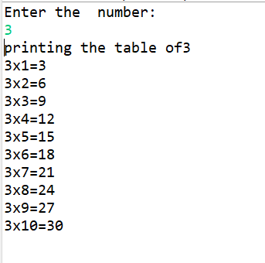

**7.     Write a program that takes a positive integer as input and prints its digits in reverse order.**

**package** Session;

**import** java.util.Scanner;

**public** **class** Reverse {

**public** **static** **void** main(String[] args) {

Scanner s = **new** Scanner(System.***in***);

System.***out***.print("Enter a number: ");

**int** number = s.nextInt();

**if** (number <= 0) {

System.***out***.println("Invalid input. Please enter a positive integer.");

**return**;

}

System.***out***.print("Digits in reverse order: ");

**while** (number > 0)

{

**int** digit = number % 10; // Get the last digit

System.***out***.print(digit); // Print the last digit

number /= 10; // Remove the last digit from the number

}

s.close();

}

}

**Output :-**

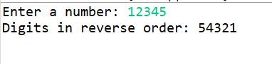

**8.     Create a class Animal with a method makeSound() that prints "Some generic animal sound". Create another class Dog that extends Animal and overrides the makeSound() method to print "Bark". Write a main method to demonstrate calling the makeSound() method on an Animal reference holding a Dog object.**

**package** Session;

//Animal class

**class** Animal {

**public** **void** makeSound() {

System.***out***.println("Some generic animal sound");

}

}

//Dog class extends Animal

**class** Dog **extends** Animal {

@Override

**public** **void** makeSound() {

System.***out***.println("Bark");

}

}

**public** **class** InhertanceAnimal {

**public** **static** **void** main(String[] args) {

Animal n = **new** Dog();

n.makeSound();

}

}

**Output :-**

